SESSION 3
NAME: P VINEETHA
REG : 192373053
COURSE: CSA0603
1.Given an m x n grid and a ball at a starting cell, find the number of ways to move
the ball out of the grid boundary in exactly N steps.
Example:
· Input: m=2,n=2,N=2,i=0,j=0 · Output: 6
· Input: m=1,n=3,N=3,i=0,j=1 · Output: 12
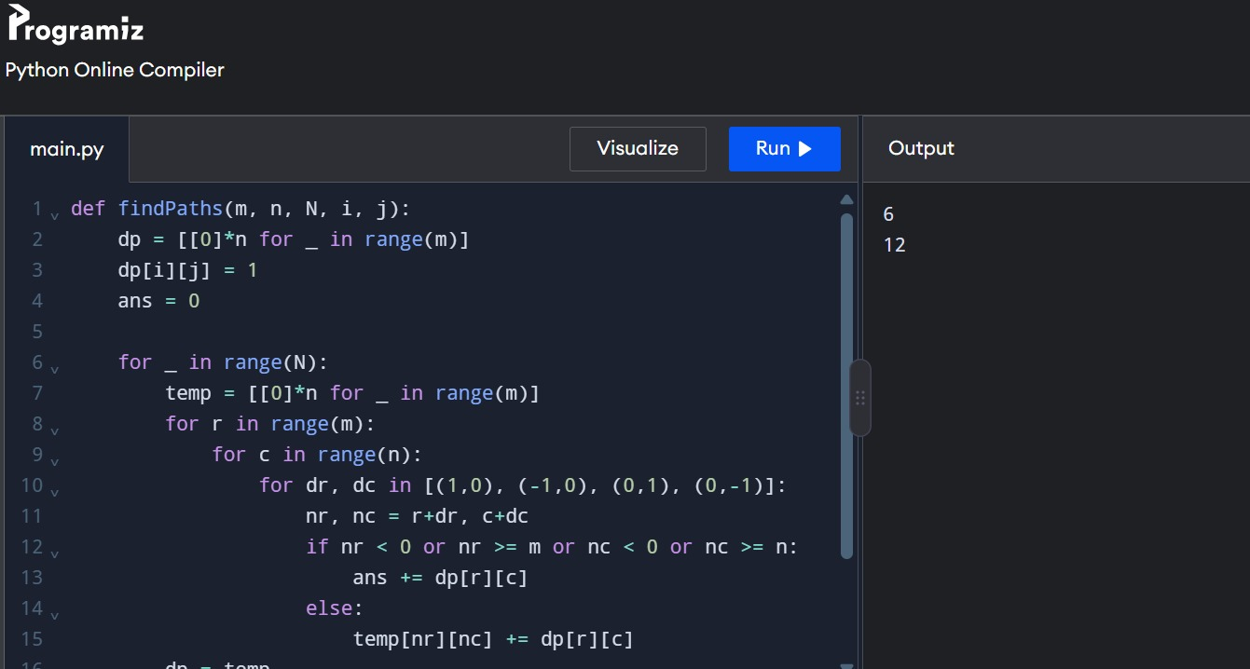
2. You are a professional robber planning to rob houses along a street. Each house
has a certain amount of money stashed. All houses at this place are arranged in a
circle. That means the first house is the neighbor of the last one. Meanwhile,
adjacent houses have security systems connected, and it will automatically
contact the police if two adjacent houses were broken into on the same night.
Examples:
Input : nums = [2, 3, 2]

Output : The maximum money you can rob without alerting the
police is 3(robbing house 1).
(ii) Input : nums = [1, 2, 3, 1]
Output : The maximum money you can rob without alerting the
police is 4 (robbing house 1 and house 3).

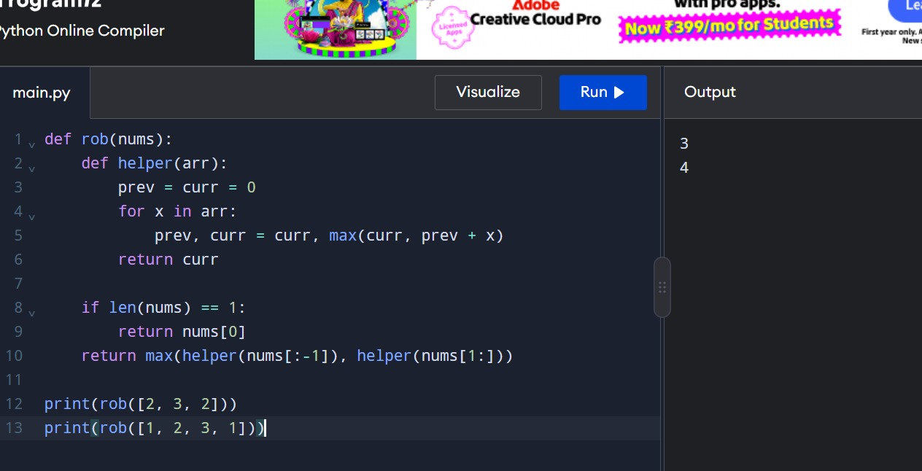
3.You are climbing a staircase. It takes n steps to reach the top. Each time you
can either climb 1 or 2 steps. In how many distinct ways can you climb to
the top?
Examples:
Input: n=4 Output: 5
Input: n=3 Output: 3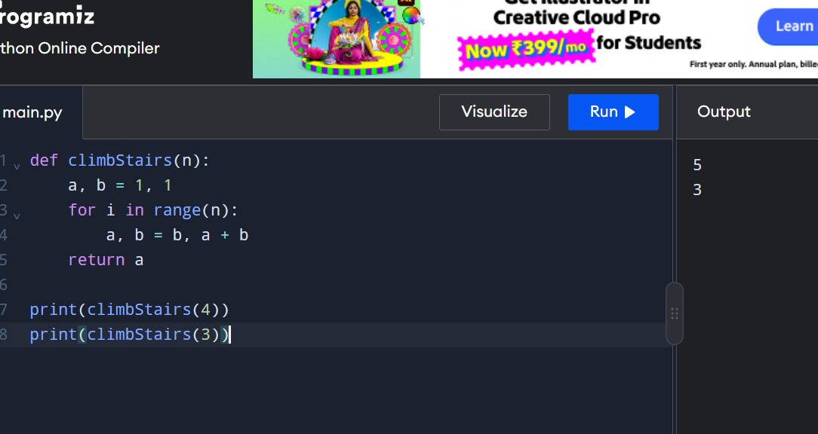
4. A robot is located at the top-left corner of a m×n grid .The robot can onlymove either down or right at any point in time. The robot is trying to
reach the bottom-right corner of the grid. How many possible unique
paths are there?
Examples:
Input: m=7,n=3 Output: 28
Input: m=3,n=2 Output: 3
